**Display sizes and costs are as follows:**

**12m x 12m (Approx 4-5 Vehicle Space) –** New Car Sales – Outdoor Lawn Area opposite Foskey Pavilion and The Bar Area – Weekend Price **$2500.00**

**5m x 3.5m** Trade Stall Booth inside Foskey Pavilion – Mezzanine Floor – Aircond. - Weekend Price **$1000.00**

**5m x 4m** Trade Stall – Outdoors between Foskey & Rotary Hall – Weekend Price **$850.00**

Our goal is to ensure that your experience at the car show exceeds expectations and delivers tangible results for your business. We believe that your company's participation as a trade stall at our inaugural car show would add tremendous value to the event and contribute to its overall success.

We are confident that you will find the experience rewarding and beneficial for your business.

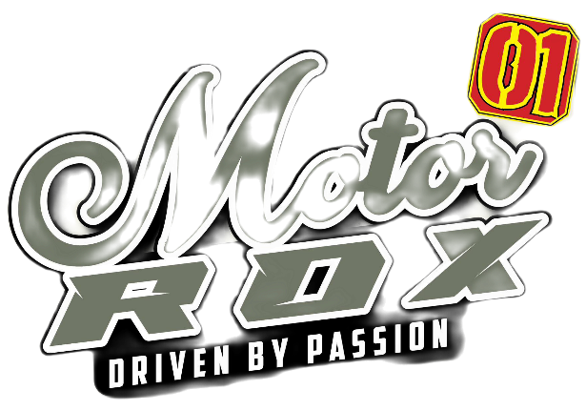Some key points for Trade Stall Holders

1. **\*Event Overview\***: The car show will take place over two days and will feature static displays, interactive experiences, educational sessions, and entertainment for attendees of all ages. It will be a prime opportunity for your company to showcase its products and services to a targeted audience of automotive enthusiasts and potential customers.

2. **\*Audience Profile\***: Our event is expected to attract a diverse audience, including car enthusiasts, motorsport participants, families, and individuals interested in automotive technology and culture. By participating as a trade stall, your company will have the opportunity to engage with this audience and promote its offerings directly.

3. **\*Networking Opportunities\***: The car show will provide ample opportunities for networking and collaboration with other participants, exhibitors, industry stakeholders and local businesses that have committed their support of our show by the way of sponsorship & trade stall investment. It will serve as a platform for forging new partnerships, building brand awareness, and generating leads for your business.

4. **\*Promotional Benefits\***: As a trade stall participant, your company will benefit from promotional exposure before, during, and after the event. We will promote your participation through our marketing channels, including social media. You will have the opportunity to display promotional banners and signage at the gate entry to the show and in the food court / family entertainment area. You will also be able to have your staff distribute advertising / promotional pamphlets throughout the venue, maximizing visibility for your products and brands.

5. **\*Customization Options\***: We understand that each exhibitor has unique requirements and objectives. Therefore, we are flexible in accommodating your specific needs and preferences regarding booth size, location, branding, and promotional activities.